

**BMW Group Financial Analysis Report — 2024**

*Prepared by: Harsh Garg*  
*Date: June 2025*

# **Executive Summary**

This report presents a comprehensive financial analysis of BMW Group based on the company’s performance over the past five years (2020–2024), with a particular focus on fiscal year 2024. The analysis covers BMW’s profitability, liquidity, leverage, operational efficiency, cash flow generation, and revenue composition by business segment.

BMW Group remains a strong player in the premium automotive sector. The company has demonstrated consistent top-line growth and maintains solid profitability, supported by a globally recognized brand portfolio and robust demand across key markets. However, Free Cash Flow to the Firm (FCFF) turned negative in 2024, reflecting heavy investments into electrification, digitalization, and factory modernization — a transition phase aligned with BMW’s long-term strategy.

# **1. Company Profile**

BMW Group (Bayerische Motoren Werke AG) is one of the world’s leading premium automotive manufacturers. Headquartered in Munich, Germany, BMW operates through three primary segments: Automotive, Motorcycles, and Financial Services. Its iconic brand portfolio includes BMW, MINI, and Rolls-Royce.

BMW continues to pursue leadership in electric mobility and connected vehicle technologies, as part of its “Neue Klasse” transformation plan, while maintaining profitability leadership in the premium segment.

|  |  |  |
| --- | --- | --- |
| • | Company Name: | BMW Group (Bayerische Motoren Werke AG) |
| • | Founded: | 1916 |
| • | Headquarters: | Munich, Germany |
| • | CEO: | Oliver Zipse (as of 2024) |
| • | Industry: | Automotive |
| • | Business Segments: | Automotive, Motorcycles, Financial Services |
| • | Brands: | BMW, MINI, Rolls-Royce |
| • | Employees: | ~ 150,000 (as per 2024 report) |
| • | Website: | [http://www.bmwgroup.com](http://www.bmwgroup.com/) |

# **2. Historical Performance (2020–2024)**

BMW’s Group Revenues expanded from €98.99 billion in 2020 to €142.38 billion in 2024 — a compound annual growth rate (CAGR) of approximately 9.5%, despite COVID-19 impacts in 2020 and supply chain disruptions during the global semiconductor shortage.

Net Profit, which peaked in 2022 at elevated margins due to favourable pricing and mix, moderated in 2024 to €7.68 billion. The reduction is attributable to higher material costs, accelerated R&D and capex for electric vehicle (EV) platforms, and general macroeconomic headwinds.

Interpretation:  
BMW’s ability to grow revenues and maintain profitability through cyclical downturns, supply shortages, and shifting consumer trends highlights the strength of its premium brand positioning. The moderate pullback in net profit in 2024 is strategically linked to the company’s deliberate investment in next-generation EV platforms — rather than an underlying deterioration in core profitability.

# **3. Income Statement Analysis**

* **Gross Profit Margin (2024):** 16.08%
* **Operating Margin (EBIT):** 8.08%
* **Net Profit Margin:** 5.39%

Interpretation:  
BMW’s Gross Margin fell slightly compared to prior years, reflecting increasing costs of batteries and raw materials for EV production, as well as increased warranty reserves as new technologies are ramped. However, the company preserved an EBIT margin of 8.08%, which remains above many mass-market competitors — underscoring BMW’s operational excellence, product mix strength, and pricing discipline. The Net Margin of 5.39% is solid for the auto industry and suggests good control of below-the-line costs, despite higher financing costs in a higher interest rate environment.

# **4. Balance Sheet Analysis**

* Total Assets (2024): €250 billion
* Debt to Equity Ratio: 1.82
* Current Ratio: 1.10

Interpretation:  
BMW’s balance sheet remains sound. The debt-to-equity ratio of 1.82 is in line with industry benchmarks for capital-intensive premium manufacturers. The increase in leverage is acceptable given the need to finance multi-billion-euro investments in battery plants and EV-related infrastructure. The Current Ratio of 1.10 indicates the company maintains adequate short-term liquidity, although it remains below the traditional 1.5x benchmark — reflecting working capital dynamics and an active debt management strategy to fund long-term capex without diluting shareholders.

# **5. Cash Flow & Free Cash Flow Analysis**

Operating Cash Flow remains positive, but 2024 saw a sharp swing in Free Cash Flow to the Firm:

* FCFF (2023): €6.66 billion
* FCFF (2024): –€4.64 billion

|  |  |  |  |  |
| --- | --- | --- | --- | --- |
| **Free Cash Flow Analysis** | | | | |
|  |
| **Metric** | **Formula** | **2024 (€M)** | **2023 (€M)** | **Interpretation** |  |
| **Free Cash Flow to the Firm (FCFF)** | *Operating Cash Flow - Capital Expenditures* | -4,639 | 6,661 | BMW didn’t generate enough free cash to cover reinvestments in assets, and support debt and euity holders. |  |
| **Free Cash Flow to Equity (FCFE)** | *Operating Cash Flow - Capital Expenditures + Net Borrowing* | 3,204 | 4,864 | BMW generates enough cash to pay shareholders or reinvest |  |

Interpretation:  
The swing in FCFF from +€6.66 billion to –€4.64 billion in 2024 signals a deliberate and expected investment cycle. BMW is currently investing heavily in factory upgrades, battery cell manufacturing partnerships, and new EV platforms, which is absorbing cash. Importantly, Free Cash Flow to Equity (FCFE) remains positive, ensuring that the company continues to generate sufficient cash to reward shareholders via dividends and buybacks — a key strength compared to competitors that are more cash-constrained during this industry transition.

# **6. Horizontal & Vertical Analysis**

**Horizontal Analysis** tells us:  
BMW’s growth has paused in 2024, as the company enters an investment-heavy phase. Profitability temporarily compressed — but not dangerously — and is consistent with EV strategy execution.

**Vertical Analysis** tells us:  
BMW remains highly efficient operationally. R&D intensity has increased (good for future competitiveness), while SG&A is well managed. Gross Margin compression reflects expected transitional cost pressures.

Both analyses **complement the ratio analysis** — they provide **context for margins and trends** that ratios alone do not explain.  
They show **how well BMW is navigating the strategic transition to EVs and digital services** — and reassure investors that current profit dips are a planned phase, not a structural weakness.

# **7. Ratio Analysis**

BMW’s financial ratios remain largely within industry norms:

* **ROE (2024):** 8.08%
* **ROA:** 2.87%
* **Debt to Equity:** 1.82
* **Current Ratio:** 1.10

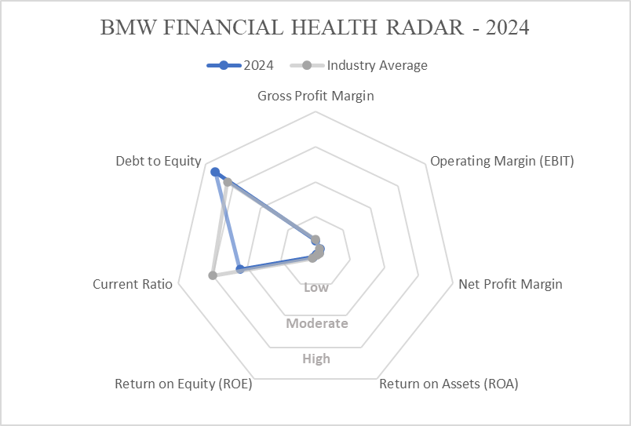

Interpretation**:**  
BMW’s ROE of 8.08% remains strong for an industrial manufacturer undergoing a capital transition, and is above the average of European mass-market OEMs. Return on Assets (ROA) of 2.87% reflects ongoing large investments in new fixed assets. Liquidity is tighter than ideal (current ratio 1.10 vs peer median ~1.5), but this is strategic, as BMW leverages its strong credit profile to optimize capital allocation during the EV shift.

# **8. Segment Revenue Analysis**

In 2024:

* **Automotive:** 75% of revenue
* **Financial Services:** 23%
* **Motorcycles:** 2%

Interpretation:  
BMW remains fundamentally an automotive manufacturer, but its Financial Services segment continues to provide earnings diversification and margin stability — particularly valuable in periods of product transition. This segment helps mitigate cyclicality in the auto business by offering leasing, financing, and mobility services. The motorcycle segment remains niche but profitable, supporting brand positioning.

# **9. Other Significant Visualisations**

# **Conclusion**

BMW Group remains in a position of strategic strength. The company has maintained profitability and financial resilience during a phase of major industry disruption. While Free Cash Flow dipped in 2024, this is consistent with a front-loaded investment strategy that should drive competitive advantage in future EV markets. Leverage remains at manageable levels, and liquidity is adequate.

BMW’s premium brand equity, global reach, and disciplined capital allocation continue to underpin shareholder value creation. Its transition toward an electrified, connected vehicle lineup is well underway, and the business appears well-positioned to generate increasing Free Cash Flow and solid returns in the medium term.

# **Appendix**

* **BMW Group Annual Report – 2024** [***Link ->***](https://github.com/HarshGarg001/BMW-Group-2024-Financial-Analysis/blob/main/BMW%20Group%20Financial%20Analysis.xlsx)
* **Source Spreadsheet:** [***BMW Group Financial Analysis.xlsx***](https://github.com/HarshGarg001/BMW-Group-2024-Financial-Analysis/blob/main/BMW%20Group%20Financial%20Analysis.xlsx)

**[END OF REPORT]**